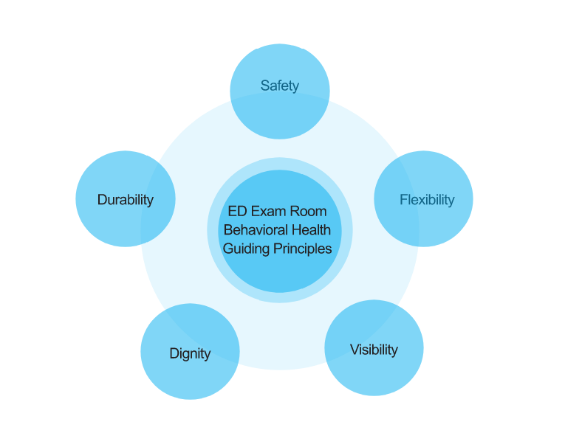
Lam Nguyen 2019-2020: Behavioral Health in the Emergency Department
This research aims to provide an overall understanding of the current challenges in the EDs in treating mentally ill children and adolescents in a typical children's hospital emergency department. Also, as the direct result of insubstantiality in federal and state funding led to limited outpatient behavioral health resources in general, and much scarce for children and adolescents specifically. Nevertheless, they were forced to come to the EDs for immediate stabilization and treatment; therefore, it presents additional burden contributing to the growing pressure on the ED system that hinders the quality of care from the healthcare standpoint and reduces patients' experience and safety drastically. It also compromises the six quality of care principles created by the Institute of Medicine (IOM): safe, effective, patient-centered, efficient, timely, and equitable.
The project book is structured into three (3) main chapters that focus on:
1.The pediatrics emergency department's history and how the sub-specialty for behavioral health children & adolescents came about.
2. The impacts of high-risk and high-stress environments on the children and adolescents with morbid mental disorders are waiting in the ED.
3. By learning from the literature reviews, interviewing EDs expert and medical planners, and drawing from evidence-based design practices, I provided some level of design recommendations and opened a discussion for future improvement and possibilities. Especially on new innovative ways that we could improve BH exam rooms and de-escalation rooms.
As designers and medical planners, we can become responsive to patient's and staff's needs for a safe and therapeutic healing environment within the pediatric psychiatric emergency department's realm.

